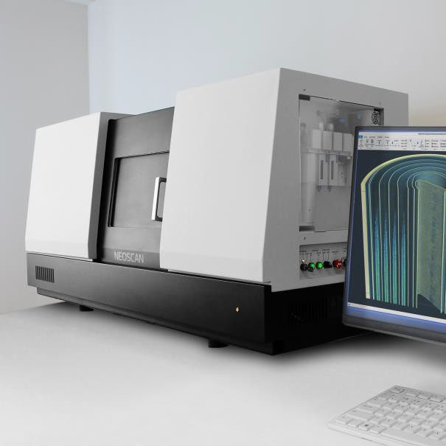
World’s first
desktop nano-CT
SPECIFICATIONS
GENERAL
APPLICATIONS
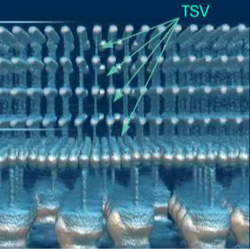
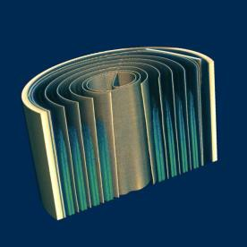
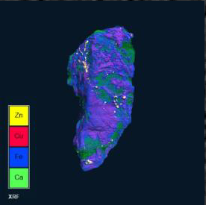
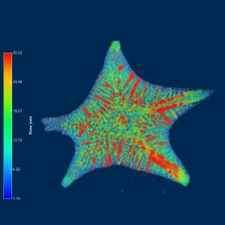
Pixel size at maximum magnification 40nm (1.5mm object) True low-contrast 3D resolution 300nm
CHALCOPYRITE
LI ION BATTERY
ADVANCED GPU
JAPANESE STARSAND
Maximum scanning diameter Ø 100mm
Maximum scanning height 200 mm
Maximum physical object length 400mm
Size (WxDxH) 1540x580x740
Weight 550kg

X-RAY SOURCE
Emitter type Transmission (open)
Energy range 20-160kV
Maximum power 16W
Smallest spot size 300nm or better Filter changer, number of positions 7

X-RAY CAMERA
Image format 27MP CMOS /
7Mp Flatpanel Protection against radiation damage Radiation hardened

OPTIONAL
Integrated full-field micro-XRF module Elemental mapping 3D NeoSpace Station 3D Spatial Reality

ACCESSORIES

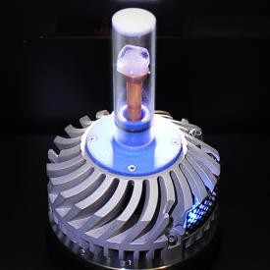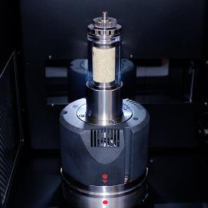
THERMAL STAGE COMPRESSION/TENSILE STAGE
-40°C below ambient up to 120°C +/-1000N





Neoscan microCT systems are supplied with an in-house developed all-in-one software tool for intuitive scanner control and processing data. From acquisition of a full series of 2D projection images, reconstruction into a 3D volume, to visualization and analysis of this volume in 2D and 3D, the software bundles all complementary steps from sample to result. The Neoscan software package includes an intuitive user interface, which will guide you through your straightforward workflow, allowing to use it instantly. All final and intermediate results are stored in conventional file formats and can be imported to any other software.

